VII. MAKING INOCULANTS

Methods of selecting Rhizobium strains, culture media, systems of growing the nodule bacteria, and processing of suitable carrier materials have already been described. This section is concerned with the actual growing of the rhizobia culture and blending it with the carrier to make an inoculant.

Growth of the rhizobia is carried out in steps. Bacteria are multiplied by transferring cultures of the organism from test tubes, to bottles or flasks, to small fermentors and then to larger fermentors as required (Figure 3). The rhizobial growth should approach the peak of the logarithmic growth phase in each step before transferring to the next larger fermentor.

In a favorable medium at 28 to 30°C and a 1% starter, the population of viable rhizobia should attain a count of 5 X 10⁸ to 1 X 10⁹ per milliliter in 60 to 72 hours. With a 3 to 5% starter, the same concentration of viable cells should be reached in 48 hours or less. With an urgent need for inoculants, larger starter inocula can be used to speed production.

A. Medium Preparation

Medium preparation can be greatly facilitated by making a composite mixture of the non-deliquescent chemical phosphates, sulfates, sodium chloride, calcium compounds, etc., and by making one weighing of the composite for each fermentor. Reagent grade chemicals are not necessary; chemicals of the U.S. Pharmacopoeia (USP) grade are satisfactory and much cheaper.

A concentrate of the medium is prepared by dissolving the ingredients of the medium in warm water and straining before adding to the fermentor vessel. The water used should be of good quality (drinkable). The medium is sterilized in the fermentor vessel. The time required for sterilization will vary with fermentor design and size. Preliminary tests should be made to measure precisely the total capacity of the fermentor and just how much time is needed at 121°C to completely sterilize that medium. The operating capacity of a fermentor is approximately 75% of its total capacity.

Tests should also be made to determine the time needed to cool the medium to 28°C before inoculating with the seed culture. It is best to make a preliminary run with tap water to determine the cooling time required.

B. Monitoring Growth of Rhizobia

Growth of rhizobia should be monitored by drawing samples at least twice daily and testing for acidity, purity and growth. The pH can be tested colorimetrically by adding 5 or 6 drops of a 0.5% w/v alcohol solution of brom-thymol-blue indicator to 8 ml of broth culture in a tube. With either fast- or slow-growing rhizobia a yellow color indicates acid conditions and probable contamination. Stained smears on microscope slides will reveal stage of growth of the rhizobia and the presence of foreign microorganisms. Rhizobia have a characteristic banded staining with basic fuchsin dye. (See Appendix B for staining procedures).

In contrast to rhizobia, most contaminating microorganisms will stain uniformly dark red with the dye, particularly the cell walls. Also, the size, shape, and arrangement of the cells are often quite different from rhizobia. The heat-resistant, spore-forming bacilli are the most common contaminants.

If there is any doubt that the bacteria are rhizobia a gram stain should be prepared (Appendix B). Rhizobia are gram-negative. Many of the contaminant microorganisms are gram-positive. They retain the crystal violet dye and will appear as blue or purple stained cells. Contaminated broth cultures should be discarded.

C. Multiple Strain Inoculants

When a multiple strain inoculum is desired, it is preferred that each strain of rhizobia be grown separately and then mixed in equal volumes at the time of making the inoculant (Figure 3). This method does not insure that there will be an equal number of rhizobia of each strain when the duct is used, but it does reduce the risk of one strain dominating the others at an early stage.

This type of production requires a greater number of culture vessels and more precise planning and scheduling. However, this should not be a major problem as long as the number of strains in any inoculum is limited to two or three. Use of multiple strain inocula does provide some protection against complete loss of effectiveness. Also, multiple strain inocula are usually effective on a wider spectrum (species and cultivars) of host plants.

D. Peat Inoculant In Bulk With Non-Sterile Carrier

The blending of a broth culture of rhizobia with the prepared carrier substance, e.g. peat, compost, bagasse, coal etc., is commonly referred to as "making the inoculant". The broth culture of undiluted and unconcentrated rhizobia is mixed with or sprayed onto the carrier in a horizontal mixer of the ribbon or paddle type. If the carrier is acid, CaCO₃ is added to neutralize acidity and raise the pH to 6.6 to 6.8. More uniform mixing and quicker action can be obtained by adding the CaCO₃ directly to the broth culture and mixing before spraying it onto the peat, but continuous agitation of the broth/CaCO₃ slurry is required to prevent settling. The moisture content will vary with different carriers but with peat, the moisture should be approximately 40% (wet basis) in the fresh inoculant.

If the carrier material is very dry, wetting it will bring about a release of energy and a rise in temperature referred to as the "heat of wetting". With continued use, heat from the mixer motor will build up and be transferred to the inoculant. Freshly prepared inoculant should be place in relatively thin layers, not over 25 to 30 cm deep in metal or fiberglass. Following mixing, the temperature should be monitored for 2 to 6 hours and should not exceed 38°C. During this period, the heat generated by the letting and mixing should be dissipated.

The curing process should take place in a clean, ventilated room maintained at a temperature of 25 to 28°C, and a relative humidity between 50 and 60% for 24 to 48 hours.

Following the curing, the inoculant should be milled or screened to break up any lumps which may have formed. It should be blended to give a homogeneous, moist powder which can be packaged easily. After curing and milling, the inoculant should either be packaged or placed in deep bins with tight covers to protect its physical condition; the material dries out rapidly when stored in shallow or open containers.

The viable count of rhizobia should increase by at least tenfold in non-sterile peat during the first 2 to 4 weeks after preparation, but this can occur only when the inoculum is kept at a temperature favorable for growth. The rhizobia cannot grow when the inoculant is stored at freezing temperatures immediately after preparation. However, rhizobia will grow once the temperature of the inoculum reaches 26 to 28°C and should incubate at this temperature for one to two weeks.

E. Soil or Granular Inoculant With Non-Sterile Carrier

The soil or granular inoculant is prepared for application directly in the seed furrow. Its necessary physical characteristics may vary depending upon the method of application to be used. When mechanical granule applicators are to be used, the material must remain very flowable. With peat granules the moisture content must be in the range of 32 to 35% (wet basis). The carrier must support growth and survival of rhizobia and at the same time maintain flowability.

If the carrier is acid, it must be neutralized. This can be done with CaCO₃. The broth culture containing the suspended CaCO₃ is sprayed onto the peat in a horizontal paddle-type mixer. The mixing must be kept to a minimum to prevent breaking up of the peat granules. Many of the same precautions are also necessary with other carriers. When the soil inoculants are to be applied by hand or other methods, flowability may not be a major consideration.

F. Pure Culture Rhizobium Inoculant

The production of peat-base inoculants which contain only rhizobia requires a completely sterile carrier in a sterile container. A flexible film bag is most convenient, but glass bottles and high density polyethylene are also used. As described earlier, sterilization is by gamma irradiation or autoclaving at 121°C. The sterile carrier facilitates rapid growth of rhizobia in the package and a longer shelf life.

The sealed package containing the sterile carrier, usually 60 to 100 g, is inoculated with a pure broth culture of rhizobia using a syringe and needle such as the Becton-Dickenson disposable plastic syringe with an 18 G needle which is 1½ (3.8 cm) inches in length. The liquid culture is mixed with the carrier by kneading the package manually (Figure 4).

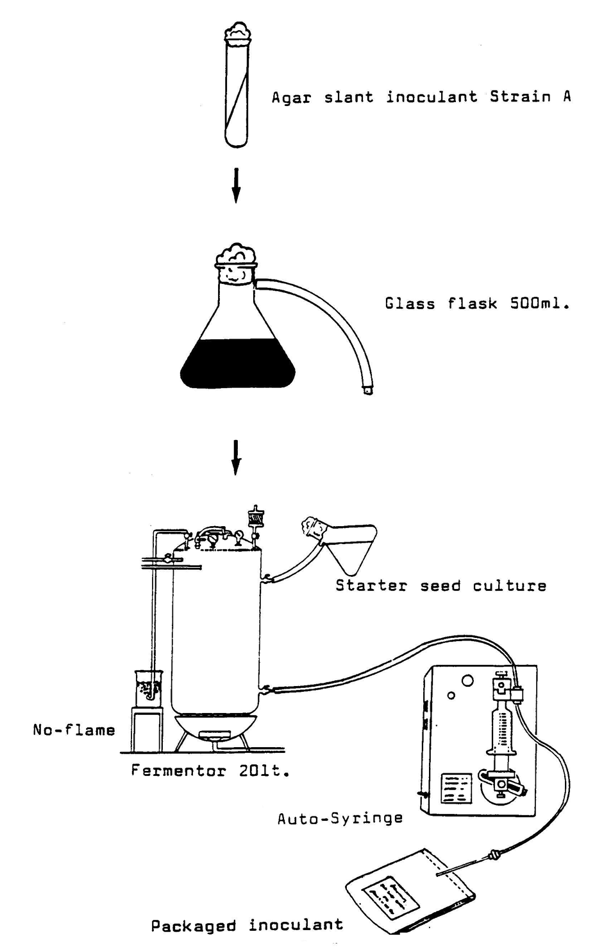

Figure 4. Pure Culture Inoculant System

This system of production is limited to small packages and is very labor intensive even when an automatic syringe is employed in dispensing the broth culture. Nonetheless, this system is being used successfully in Australia and other places where pure cultures of rhizobia are considered necessary and sufficiently advantageous to justify the additional cost.

